**WEEK 4 HANDS ON EXERCISE – SPRING REST USING SPRING BOOT3**

**Exercise : Create a Spring Web Project using Maven**

**PROBLEM STATEMENT :**

Create a basic Spring Boot Web project using Maven to understand the project structure, configuration files, and how to run the application in Eclipse. Set up proxy settings for Maven build and explore key components like src, pom.xml, and the @SpringBootApplication annotation.

**CODE :**

**SpringLearnApplication.java**

import org.springframework.boot.SpringApplication;

import org.springframework.boot.autoconfigure.SpringBootApplication;

@SpringBootApplication

public class SpringLearnApplication

{

    public static void main(String[] args)

    {

          System.out.println(">>>>> SpringLearnApplication main() started <<<<<");

        SpringApplication.run(SpringLearnApplication.class, args);

    }

}

**pom.xml**

<?xml version="1.0" encoding="UTF-8"?>

<project xmlns="http://maven.apache.org/POM/4.0.0" xmlns:xsi="http://www.w3.org/2001/XMLSchema-instance"

    xsi:schemaLocation="http://maven.apache.org/POM/4.0.0 https://maven.apache.org/xsd/maven-4.0.0.xsd">

    <modelVersion>4.0.0</modelVersion>

    <parent>

        <groupId>org.springframework.boot</groupId>

        <artifactId>spring-boot-starter-parent</artifactId>

        <version>3.5.3</version>

        <relativePath/> <!-- lookup parent from repository -->

    </parent>

    <groupId>com.cognizant</groupId>

    <artifactId>spring-learn</artifactId>

    <version>0.0.1-SNAPSHOT</version>

    <name>spring-learn</name>

    <description>Demo project for Spring Boot</description>

    <url/>

    <licenses>

        <license/>

    </licenses>

    <developers>

        <developer/>

    </developers>

    <scm>

        <connection/>

        <developerConnection/>

        <tag/>

        <url/>

    </scm>

    <properties>

        <java.version>17</java.version>

    </properties>

    <dependencies>

        <dependency>

            <groupId>org.springframework.boot</groupId>

            <artifactId>spring-boot-starter-web</artifactId>

        </dependency>

        <dependency>

            <groupId>org.springframework.boot</groupId>

            <artifactId>spring-boot-devtools</artifactId>

            <scope>runtime</scope>

            <optional>true</optional>

        </dependency>

        <dependency>

            <groupId>org.springframework.boot</groupId>

            <artifactId>spring-boot-starter-test</artifactId>

            <scope>test</scope>

        </dependency>

        <dependency>

    <groupId>org.springframework.boot</groupId>

    <artifactId>spring-boot-starter-logging</artifactId>

</dependency>

    </dependencies>

    <build>

        <plugins>

            <plugin>

                <groupId>org.springframework.boot</groupId>

                <artifactId>spring-boot-maven-plugin</artifactId>

            </plugin>

        </plugins>

    </build>

</project>

**OUTPUT :**

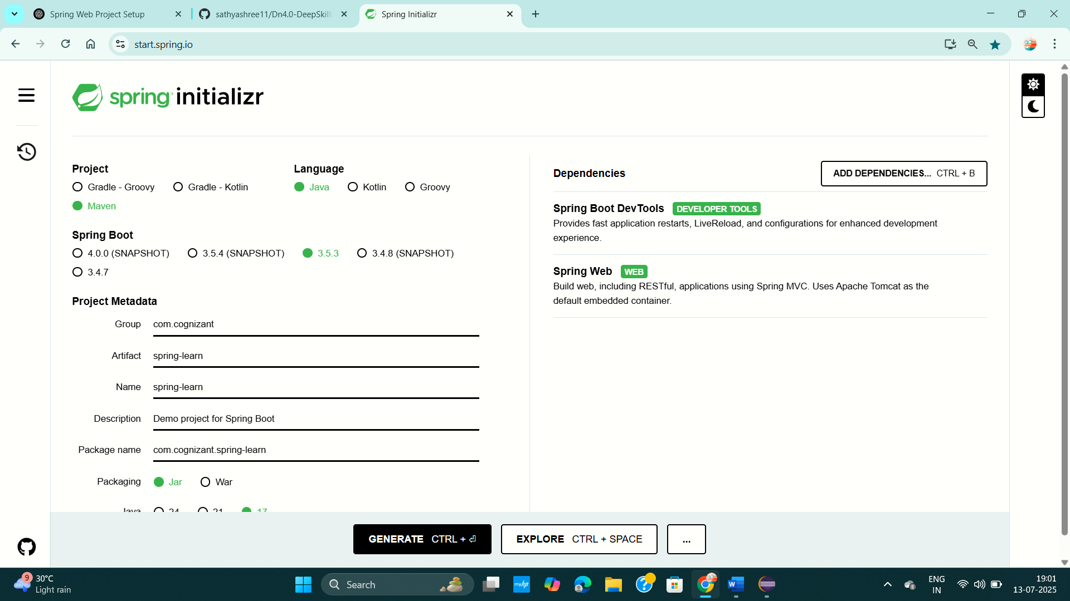

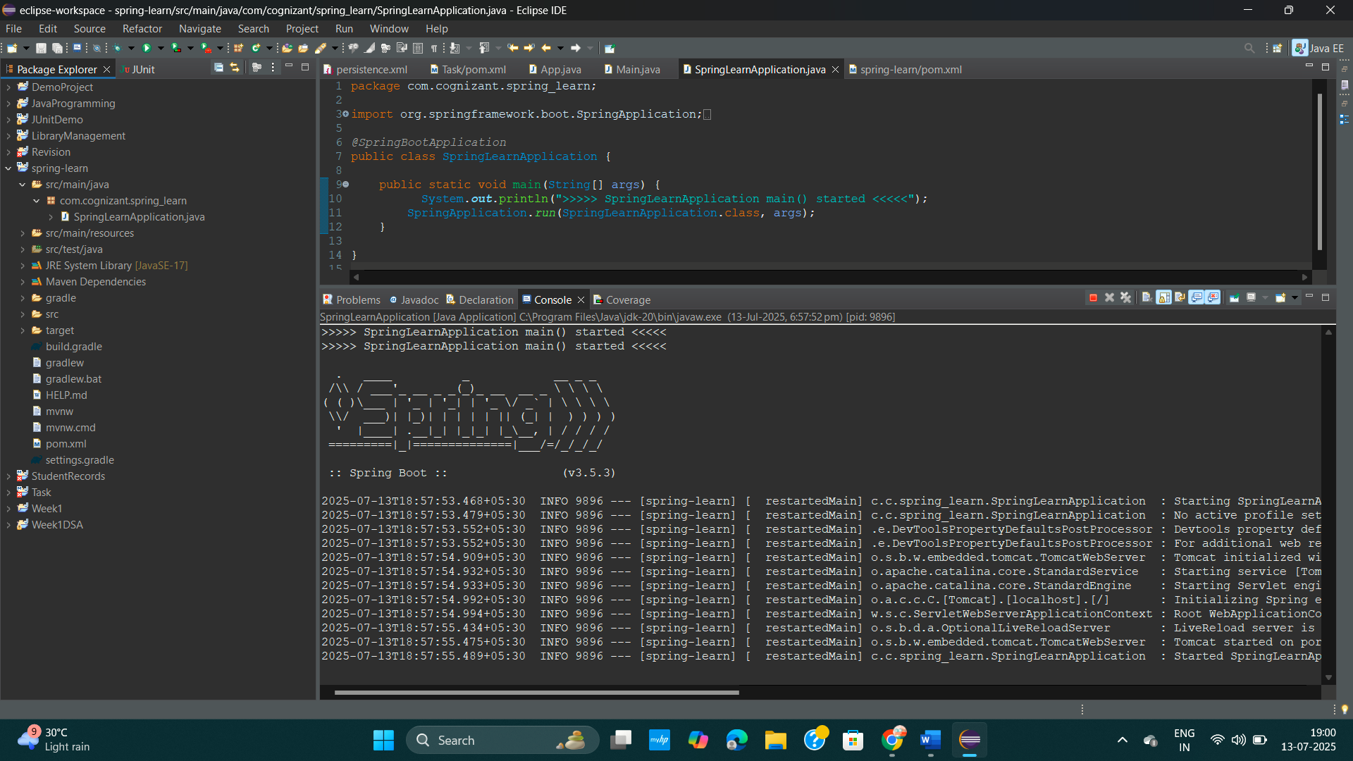

**Exercise : Spring Core – Load Country from Spring Configuration XML**

**PROBLEM STATEMENT :**

An airlines website is going to support booking on four countries. There will be a drop down on the home page of this website to select the respective country. It is also important to store the two-character ISO code of each country. 

**CODE :**

**Country.java**

package com.cognizant.spring_learn;

import org.slf4j.Logger;

import org.slf4j.LoggerFactory;

public class Country

{

private static final Logger ***LOGGER*** = LoggerFactory.*getLogger*(Country.class);

private String code;

private String name;

public Country() {

***LOGGER***.debug("Inside Country Constructor.");

}

public String getCode() {

***LOGGER***.debug("Inside getCode()");

return code;

}

public void setCode(String code) {

***LOGGER***.debug("Inside setCode()");

this.code = code;

}

public String getName() {

***LOGGER***.debug("Inside getName()");

return name;

}

public void setName(String name) {

***LOGGER***.debug("Inside setName()");

this.name = name;

}

*@Override*

public String toString() {

return "Country [code=" + code + ", name=" + name + "]";

}

}

**SpringLearnApplication.java**

package com.cognizant.spring_learn;

import org.slf4j.Logger;

import org.slf4j.LoggerFactory;

import org.springframework.boot.SpringApplication;

import org.springframework.boot.autoconfigure.SpringBootApplication;

import org.springframework.context.ApplicationContext;

import org.springframework.context.support.ClassPathXmlApplicationContext;

*@SpringBootApplication*

public class SpringLearnApplication {

private static final Logger ***LOGGER*** = LoggerFactory.*getLogger*(SpringLearnApplication.class);

public static void main(String[] args) {

***LOGGER***.info("START");

SpringApplication.*run*(SpringLearnApplication.class, args);

*displayCountry*();

***LOGGER***.info("END");

}

public static void displayCountry() {

ApplicationContext context = new ClassPathXmlApplicationContext("country.xml");

Country country = context.getBean("country", Country.class);

***LOGGER***.debug("Country : {}", country.toString());

}

}

**Country.xml**

<?xml version="1.0" encoding="UTF-8"?>

<beans xmlns="http://www.springframework.org/schema/beans"

xmlns:xsi="http://www.w3.org/2001/XMLSchema-instance"

xsi:schemaLocation="

http://www.springframework.org/schema/beans

http://www.springframework.org/schema/beans/spring-beans.xsd">

<bean id="country" class="com.cognizant.spring_learn.Country">

<property name="code" value="IN" />

<property name="name" value="India" />

</bean>

</beans>

**application.properties**

spring.application.name=spring-learn

logging.level.com.cognizant.spring_learn=DEBUG

**pom.xml**

<?xml version="1.0" encoding="UTF-8"?>

<project xmlns="http://maven.apache.org/POM/4.0.0" xmlns:xsi="http://www.w3.org/2001/XMLSchema-instance"

xsi:schemaLocation="http://maven.apache.org/POM/4.0.0 https://maven.apache.org/xsd/maven-4.0.0.xsd">

<modelVersion>4.0.0</modelVersion>

<parent>

<groupId>org.springframework.boot</groupId>

<artifactId>spring-boot-starter-parent</artifactId>

<version>3.5.3</version>

<relativePath/> <!-- lookup parent from repository -->

</parent>

<groupId>com.cognizant</groupId>

<artifactId>spring-learn</artifactId>

<version>0.0.1-SNAPSHOT</version>

<name>spring-learn</name>

<description>Demo project for Spring Boot</description>

<url/>

<licenses>

<license/>

</licenses>

<developers>

<developer/>

</developers>

<scm>

<connection/>

<developerConnection/>

<tag/>

<url/>

</scm>

<properties>

<java.version>17</java.version>

</properties>

<dependencies>

<dependency>

<groupId>org.springframework.boot</groupId>

<artifactId>spring-boot-starter-web</artifactId>

</dependency>

<dependency>

<groupId>org.springframework.boot</groupId>

<artifactId>spring-boot-devtools</artifactId>

<scope>runtime</scope>

<optional>true</optional>

</dependency>

<dependency>

<groupId>org.springframework.boot</groupId>

<artifactId>spring-boot-starter-test</artifactId>

<scope>test</scope>

</dependency>

<dependency>

<groupId>org.springframework.boot</groupId>

<artifactId>spring-boot-starter-logging</artifactId>

</dependency>

</dependencies>

<build>

<plugins>

<plugin>

<groupId>org.springframework.boot</groupId>

<artifactId>spring-boot-maven-plugin</artifactId>

</plugin>

</plugins>

</build>

</project>

**OUTPUT :**

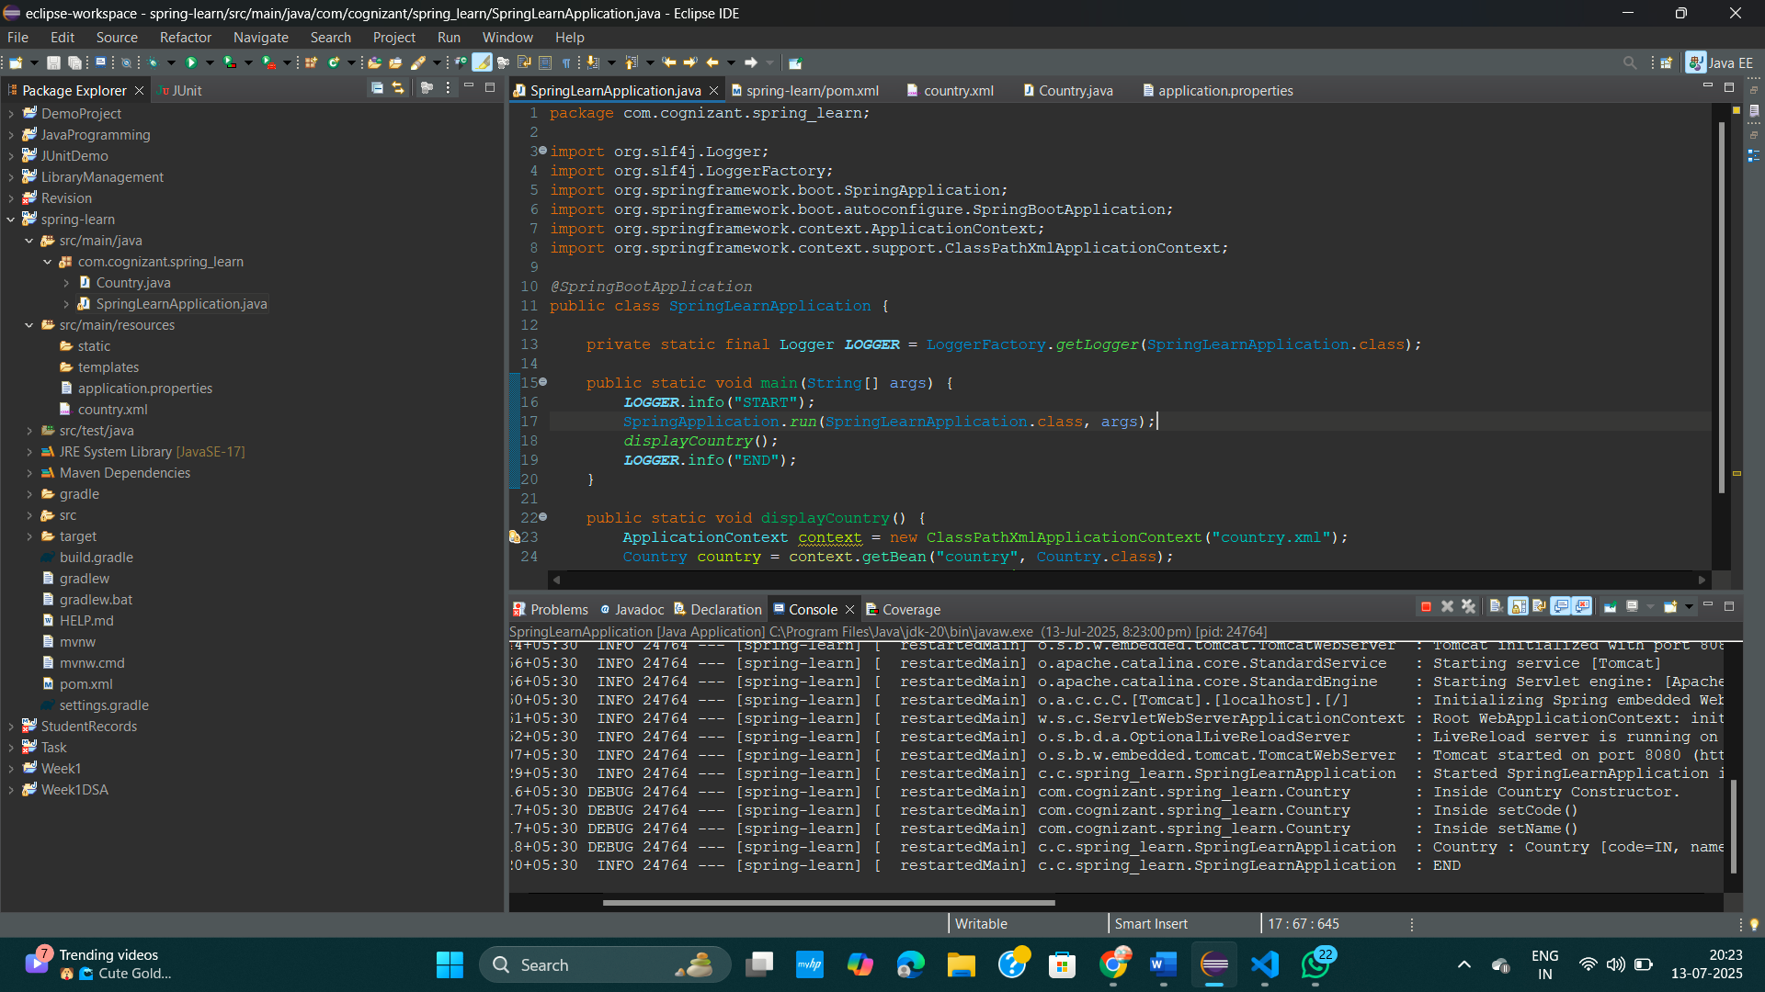

**Exercise : Hello World RESTful Web Service**

**PROBLEM STATEMENT:**

Write a REST service in the spring learn application created earlier, that returns the text "Hello World!!" using Spring Web Framework.

**CODE :**

**HelloController.java**

package com.cognizant.spring_learn.controller;

import org.slf4j.Logger;

import org.slf4j.LoggerFactory;

import org.springframework.web.bind.annotation.GetMapping;

import org.springframework.web.bind.annotation.RestController;

*@RestController*

public class HelloController {

private static final Logger ***LOGGER*** = LoggerFactory.*getLogger*(HelloController.class);

*@GetMapping*("/hello")

public String sayHello() {

***LOGGER***.info("START");

String message = "Hello World!! This is Exercise - 3 Spring Restful Web Service. ";

***LOGGER***.info("END");

return message;

}

}

**application.properties**

spring.application.name=spring-learn

logging.level.com.cognizant.spring_learn=DEBUG

server.port=8083

**pom.xml**

<?xml version="1.0" encoding="UTF-8"?>

<project xmlns="http://maven.apache.org/POM/4.0.0" xmlns:xsi="http://www.w3.org/2001/XMLSchema-instance"

xsi:schemaLocation="http://maven.apache.org/POM/4.0.0 https://maven.apache.org/xsd/maven-4.0.0.xsd">

<modelVersion>4.0.0</modelVersion>

<parent>

<groupId>org.springframework.boot</groupId>

<artifactId>spring-boot-starter-parent</artifactId>

<version>3.5.3</version>

<relativePath/> <!-- lookup parent from repository -->

</parent>

<groupId>com.cognizant</groupId>

<artifactId>spring-learn</artifactId>

<version>0.0.1-SNAPSHOT</version>

<name>spring-learn</name>

<description>Demo project for Spring Boot</description>

<url/>

<licenses>

<license/>

</licenses>

<developers>

<developer/>

</developers>

<scm>

<connection/>

<developerConnection/>

<tag/>

<url/>

</scm>

<properties>

<java.version>17</java.version>

</properties>

<dependencies>

<dependency>

<groupId>org.springframework.boot</groupId>

<artifactId>spring-boot-starter-web</artifactId>

</dependency>

<dependency>

<groupId>org.springframework.boot</groupId>

<artifactId>spring-boot-devtools</artifactId>

<scope>runtime</scope>

<optional>true</optional>

</dependency>

<dependency>

<groupId>org.springframework.boot</groupId>

<artifactId>spring-boot-starter-test</artifactId>

<scope>test</scope>

</dependency>

<dependency>

<groupId>org.springframework.boot</groupId>

<artifactId>spring-boot-starter-logging</artifactId>

</dependency>

</dependencies>

<build>

<plugins>

<plugin>

<groupId>org.springframework.boot</groupId>

<artifactId>spring-boot-maven-plugin</artifactId>

</plugin>

</plugins>

</build>

</project>

**OUTPUT :**

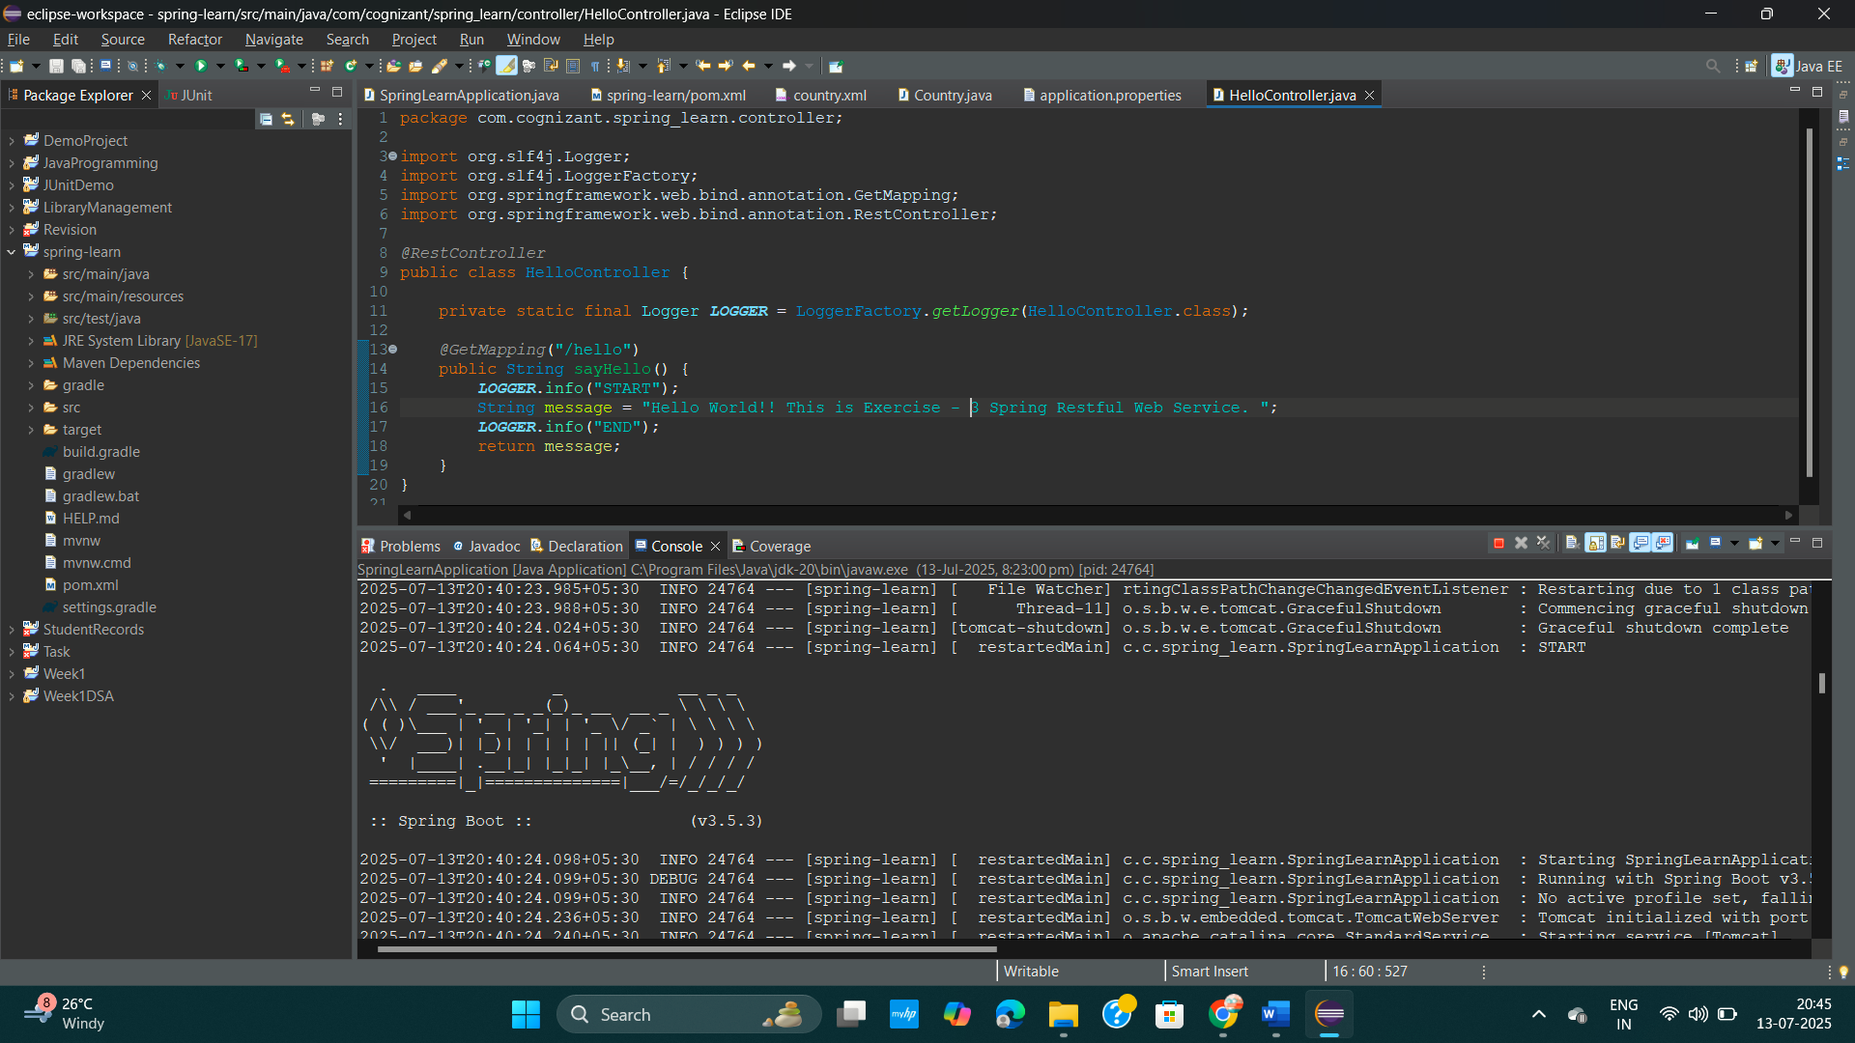

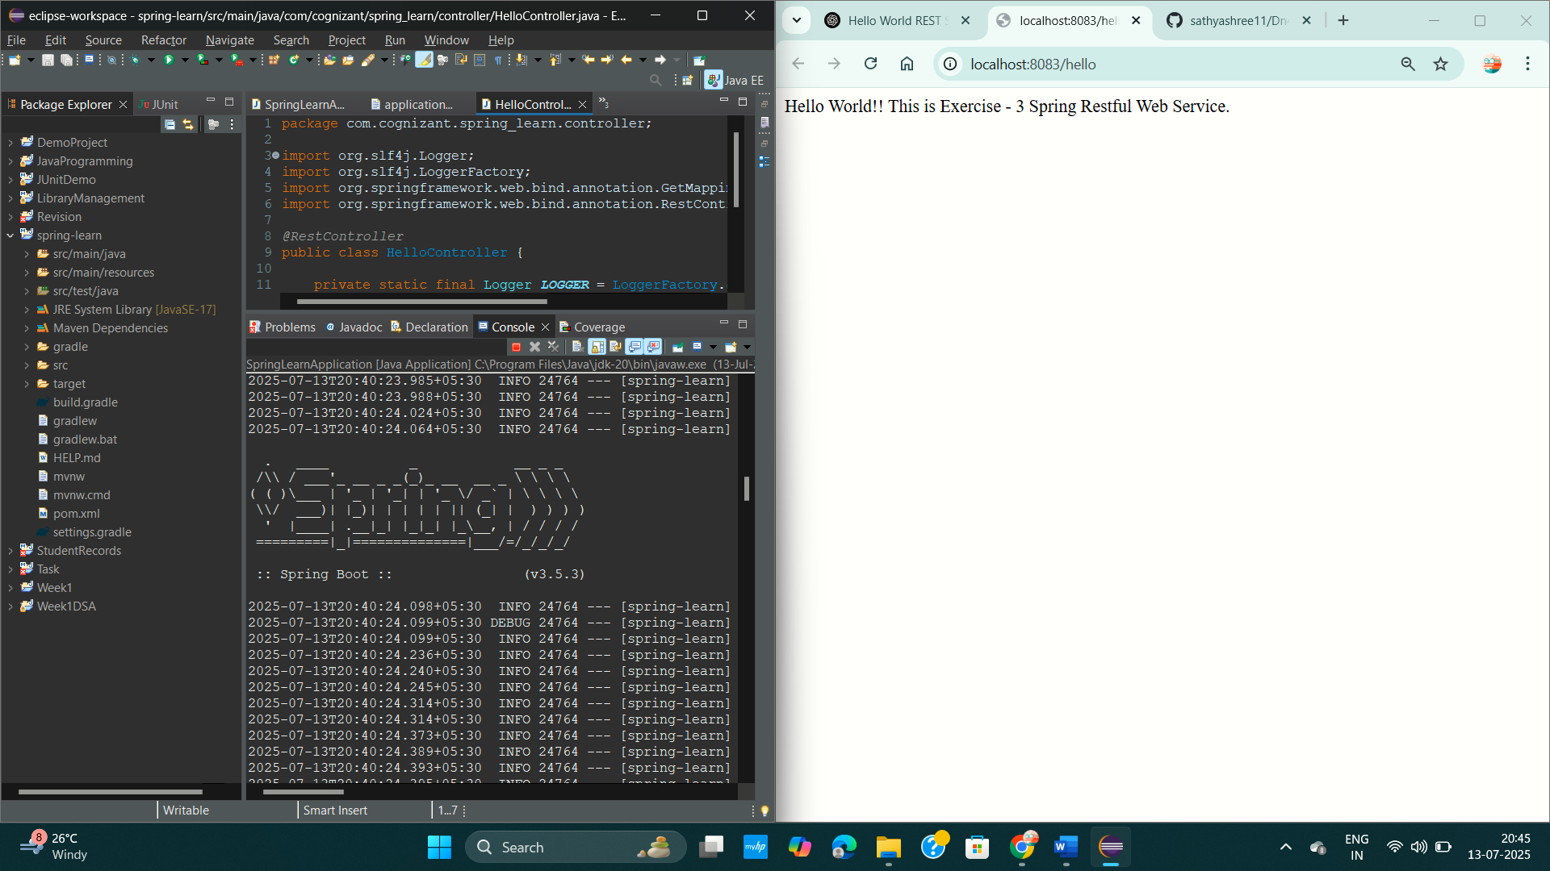

**Exercise : REST - Country Web Service**

**PROBLEM STATEMENT:**

Write a REST service that returns India country details in the earlier created spring learn application.

**CODE :**

**CountryController.java**

package com.cognizant.spring_learn.controller;

import org.springframework.context.ApplicationContext;

import org.springframework.context.support.ClassPathXmlApplicationContext;

import org.springframework.web.bind.annotation.RequestMapping;

import org.springframework.web.bind.annotation.RestController;

import com.cognizant.spring_learn.Country;

*@RestController*

public class CountryController {

*@RequestMapping*("/country")

public Country getCountryIndia() {

ApplicationContext context = new ClassPathXmlApplicationContext("country.xml");

Country country = (Country) context.getBean("country");

return country;

}

}

**Country.xml**

<?xml version="1.0" encoding="UTF-8"?>

<beans xmlns="http://www.springframework.org/schema/beans"

xmlns:xsi="http://www.w3.org/2001/XMLSchema-instance"

xsi:schemaLocation="

http://www.springframework.org/schema/beans

http://www.springframework.org/schema/beans/spring-beans.xsd">

<bean id="country" class="com.cognizant.spring_learn.Country">

<property name="code" value="IN" />

<property name="name" value="India" />

</bean>

</beans>

**application.properties**

spring.application.name=spring-learn

logging.level.com.cognizant.spring_learn=DEBUG

server.port=8083

**OUTPUT :**

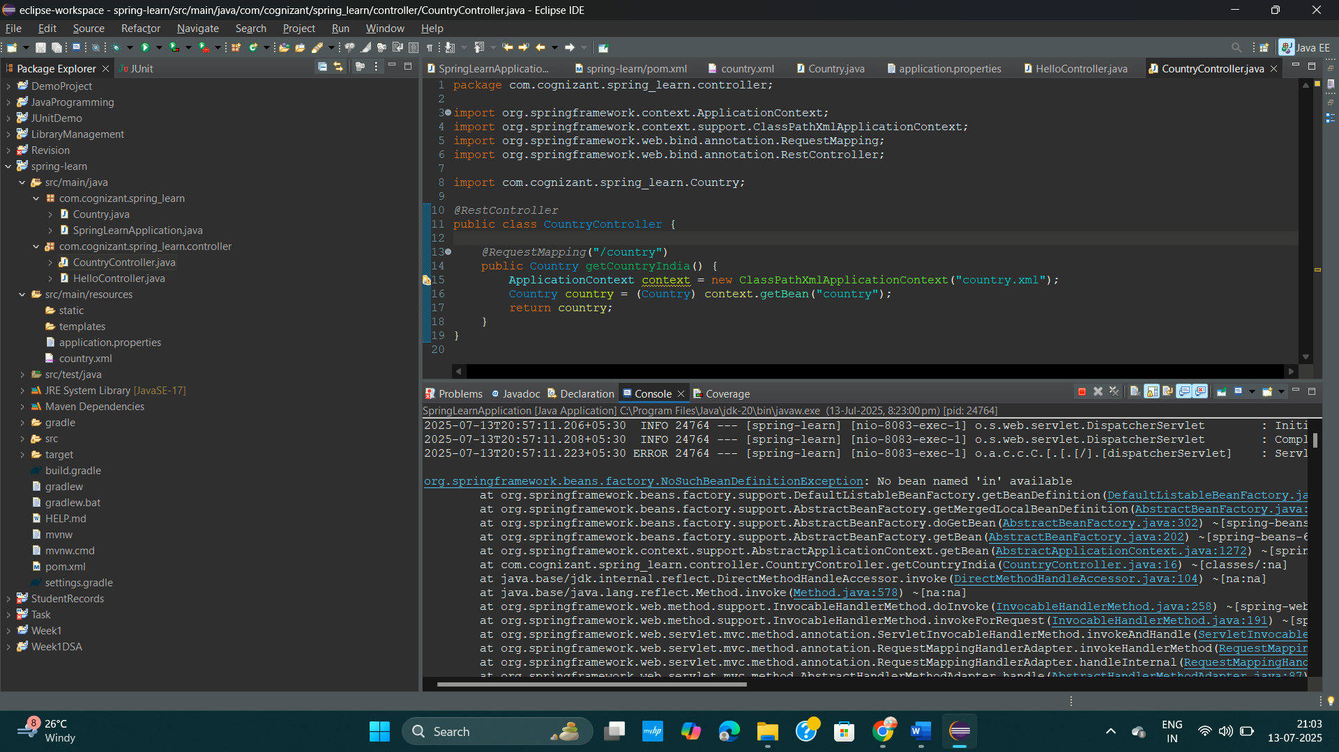

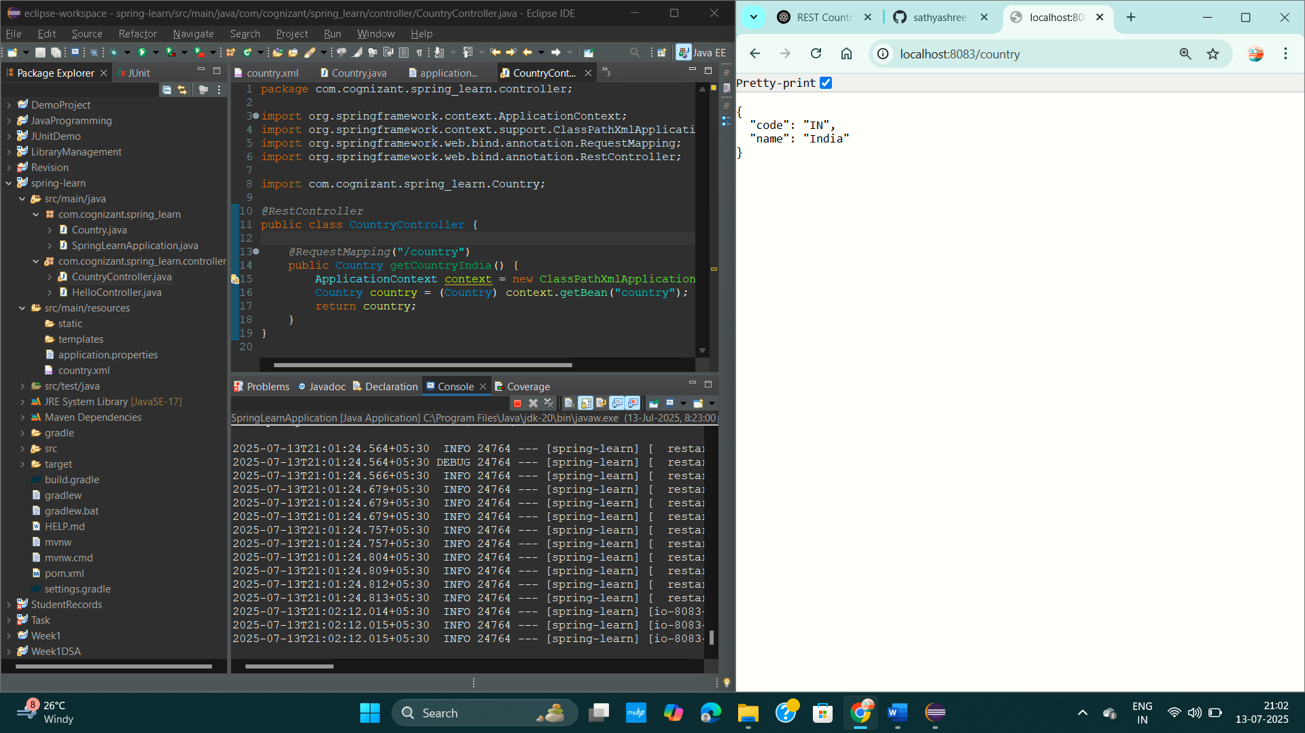

**Exercise : REST - Get country based on country code**

**PROBLEM STATEMENT :**

Write a REST service that returns a specific country based on country code. The country code should be case insensitive.

**CODE :**

**Country.java**

package com.cognizant.spring_learn;

public class Country {

private String code;

private String name;

// Getters and setters

public String getCode() {

return code;

}

public void setCode(String code) {

this.code = code;

}

public String getName() {

return name;

}

public void setName(String name) {

this.name = name;

}

// Optional: toString()

*@Override*

public String toString() {

return "Country [code=" + code + ", name=" + name + "]";

}

}

**CountryController.java**

package com.cognizant.spring_learn.controller;

import org.springframework.beans.factory.annotation.Autowired;

import org.springframework.web.bind.annotation.*;

import com.cognizant.spring_learn.Country;

import com.cognizant.spring_learn.service.CountryService;

*@RestController*

public class CountryController {

*@Autowired*

private CountryService countryService;

*@GetMapping*("/countries/{code}")

public Country getCountry(*@PathVariable* String code) throws Exception {

return countryService.getCountry(code);

}

}

**CountryService.java**

package com.cognizant.spring_learn.service;

import java.util.List;

import org.springframework.beans.factory.annotation.Autowired;

import org.springframework.stereotype.Service;

import com.cognizant.spring_learn.Country;

import org.springframework.context.ApplicationContext;

import org.springframework.context.support.ClassPathXmlApplicationContext;

*@Service*

public class CountryService {

public Country getCountry(String code) throws Exception {

ApplicationContext context = new ClassPathXmlApplicationContext("country.xml");

List<Country> countries = (List<Country>) context.getBean("countryList");

return countries.stream()

.filter(c -> c.getCode().equalsIgnoreCase(code))

.findFirst()

.orElseThrow(() -> new Exception("Country not found"));

}

}

**country.xml**

<?xml version="1.0" encoding="UTF-8"?>

<beans xmlns="http://www.springframework.org/schema/beans"

xmlns:xsi="http://www.w3.org/2001/XMLSchema-instance"

xsi:schemaLocation="

http://www.springframework.org/schema/beans

http://www.springframework.org/schema/beans/spring-beans.xsd">

<bean id="country1" class="com.cognizant.spring_learn.Country">

<property name="code" value="IN"/>

<property name="name" value="India - Variation"/>

</bean>

<bean id="country2" class="com.cognizant.spring_learn.Country">

<property name="code" value="US"/>

<property name="name" value="United States"/>

</bean>

<bean id="country3" class="com.cognizant.spring_learn.Country">

<property name="code" value="FR"/>

<property name="name" value="France"/>

</bean>

<bean id="countryList" class="java.util.ArrayList">

<constructor-arg>

<list>

<ref bean="country1"/>

<ref bean="country2"/>

<ref bean="country3"/>

</list>

</constructor-arg>

</bean>

</beans>

**pom.xml**

<?xml version="1.0" encoding="UTF-8"?>

<project xmlns="http://maven.apache.org/POM/4.0.0" xmlns:xsi="http://www.w3.org/2001/XMLSchema-instance"

xsi:schemaLocation="http://maven.apache.org/POM/4.0.0 https://maven.apache.org/xsd/maven-4.0.0.xsd">

<modelVersion>4.0.0</modelVersion>

<parent>

<groupId>org.springframework.boot</groupId>

<artifactId>spring-boot-starter-parent</artifactId>

<version>3.5.3</version>

<relativePath/> <!-- lookup parent from repository -->

</parent>

<groupId>com.cognizant</groupId>

<artifactId>spring-learn</artifactId>

<version>0.0.1-SNAPSHOT</version>

<name>spring-learn</name>

<description>Demo project for Spring Boot</description>

<url/>

<licenses>

<license/>

</licenses>

<developers>

<developer/>

</developers>

<scm>

<connection/>

<developerConnection/>

<tag/>

<url/>

</scm>

<properties>

<java.version>17</java.version>

</properties>

<dependencies>

<dependency>

<groupId>org.springframework.boot</groupId>

<artifactId>spring-boot-starter-web</artifactId>

</dependency>

<dependency>

<groupId>org.springframework.boot</groupId>

<artifactId>spring-boot-devtools</artifactId>

<scope>runtime</scope>

<optional>true</optional>

</dependency>

<dependency>

<groupId>org.springframework.boot</groupId>

<artifactId>spring-boot-starter-test</artifactId>

<scope>test</scope>

</dependency>

<dependency>

<groupId>org.springframework.boot</groupId>

<artifactId>spring-boot-starter-logging</artifactId>

</dependency>

</dependencies>

<build>

<plugins>

<plugin>

<groupId>org.springframework.boot</groupId>

<artifactId>spring-boot-maven-plugin</artifactId>

</plugin>

</plugins>

</build>

</project>

**OUTPUT :**

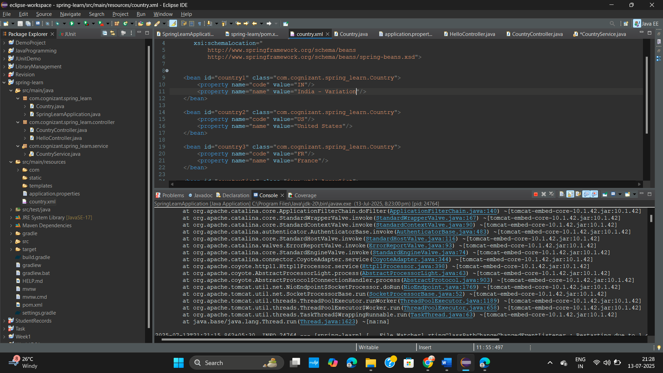

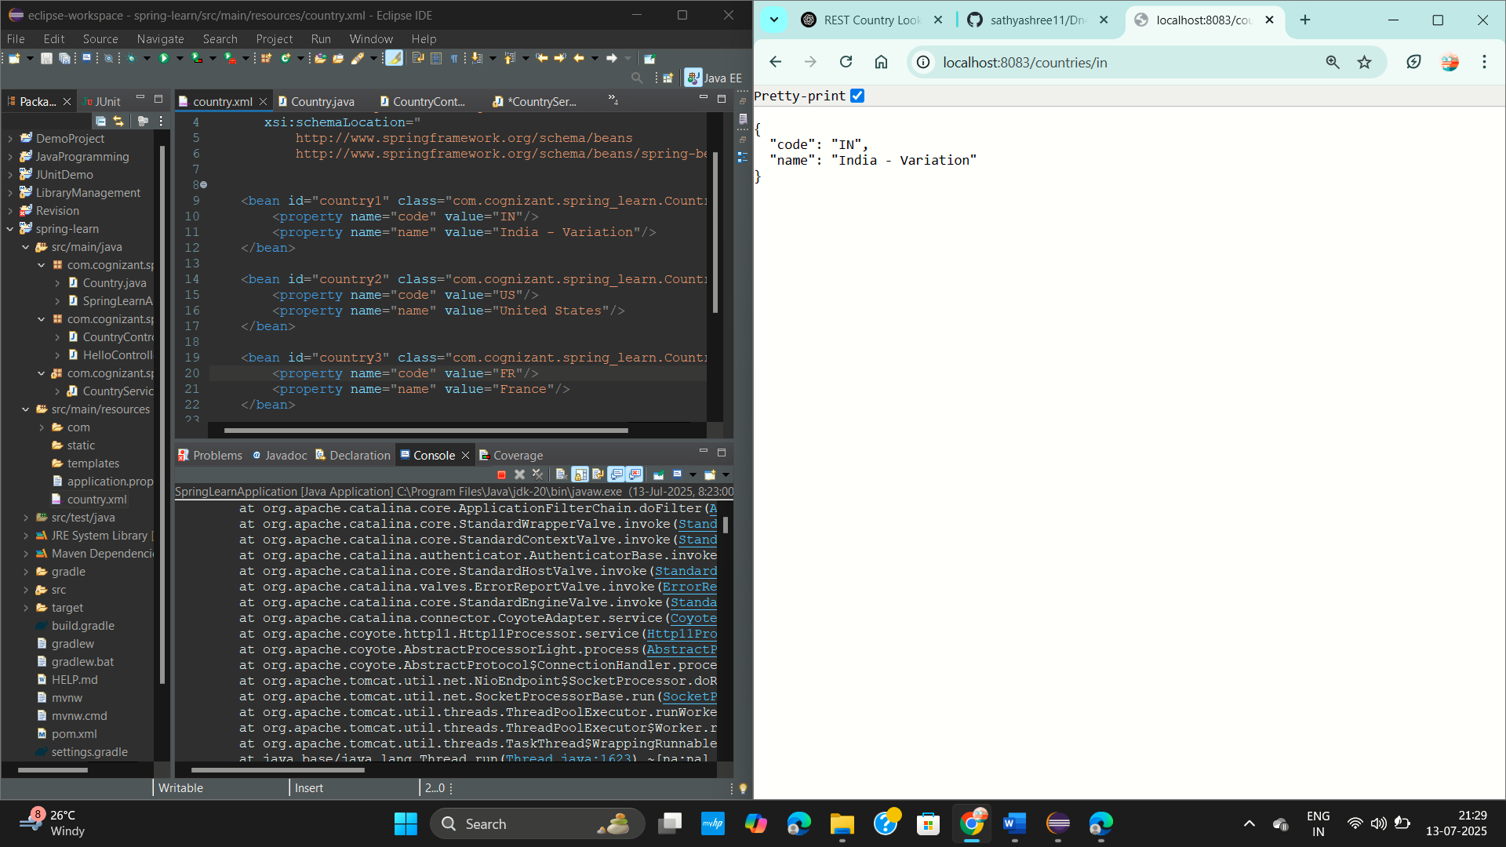

**Exercise : Create authentication service that returns JWT**

**PROBLEM STATEMENT:**

As the first step in the JWT authentication process, the user's login credentials need to be sent to an authentication service, which validates the credentials and returns a JWT (JSON Web Token) for secure communication in subsequent requests.

**CODE :**

**AuthController.java**

package com.example.jwt;

import org.springframework.web.bind.annotation.*;

import org.springframework.beans.factory.annotation.Autowired;

import org.springframework.http.ResponseEntity;

import jakarta.servlet.http.HttpServletRequest;

import java.util.Base64;

*@RestController*

public class AuthController {

*@Autowired*

private JwtUtil jwtUtil;

*@GetMapping*("/authenticate")

public ResponseEntity<?> authenticate(HttpServletRequest request) {

String authHeader = request.getHeader("Authorization");

if (authHeader == null || !authHeader.startsWith("Basic ")) {

return ResponseEntity.*status*(401).body("Missing or invalid Authorization header.");

}

String base64Credentials = authHeader.substring("Basic ".length());

String credentials = new String(Base64.*getDecoder*().decode(base64Credentials));

String[] values = credentials.split(":", 2);

if (values.length != 2) {

return ResponseEntity.*status*(400).body("Invalid authentication format.");

}

String username = values[0];

String password = values[1];

if ("user".equals(username) && "pwd".equals(password)) {

String token = jwtUtil.generateToken(username);

return ResponseEntity.*ok*("{\"token\":\"" + token + "\"}");

} else {

return ResponseEntity.*status*(401).body("Invalid credentials.");

}

}

}

**JwtUtill.java**

package com.example.jwt;

import io.jsonwebtoken.Jwts;

import io.jsonwebtoken.SignatureAlgorithm;

import org.springframework.stereotype.Component;

import java.util.Date;

*@Component*

public class JwtUtil {

private final String SECRET_KEY = "secret"; // Use secure key in real apps

public String generateToken(String username) {

long nowMillis = System.*currentTimeMillis*();

return Jwts.*builder*()

.setSubject(username)

.setIssuedAt(new Date(nowMillis))

.setExpiration(new Date(nowMillis + 600000)) // 10 minutes

.signWith(*SignatureAlgorithm*.***HS256***, SECRET_KEY)

.compact();

}

}

**MyApplication.java**

package com.example.jwt;

import org.springframework.boot.SpringApplication;

import org.springframework.boot.autoconfigure.SpringBootApplication;

*@SpringBootApplication*

public class MyApplication {

public static void main(String[] args) {

SpringApplication.*run*(MyApplication.class, args);

}

}

**SecutiryConfig.java**

package com.example.jwt.config;

import org.springframework.context.annotation.Bean;

import org.springframework.context.annotation.Configuration;

import org.springframework.security.config.annotation.web.builders.HttpSecurity;

import org.springframework.security.web.SecurityFilterChain;

*@Configuration*

public class SecurityConfig {

*@Bean*

public SecurityFilterChain filterChain(HttpSecurity http) throws Exception {

http.~~csrf~~().disable()

.authorizeHttpRequests(auth -> auth

.requestMatchers("/authenticate").permitAll()

.anyRequest().authenticated()

);

return http.build();

}

}

**OUTPUT :**

